
St. Edmund’s Catholic Primary School
Hertford Road, Edmonton, London, N9 7HJ

Phone 0208 8072664
Facsimile 0208 8078877
office@st-edmunds.enfield.sch.uk
Headteacher: Mr D. Abrahams, B.Ed Hons
Deputy Headteacher:Ms E Graves (Acting), BA

Autumn 2025

Admission Reception September 2026

Dear Parent/Carer,

Thank you for your interest in our school. St Edmund’s provides an excellent Catholic education for children between the ages of four and eleven in an environment that nurtures the Catholic faith.

You must fill in 2 application forms, one for the school and one for the Local Authority.

Enclosed you will find a copy of St Edmund’s Admission’s Policy a Supplementary Information Form and other relavant information. Once completed, these forms should be returned to the school office along with evidence of the child’s date of birth, their baptismal certificate (if applicable), a Certificate of Catholic Practice which is available from the parish in which you practice (if applicable), plus 2 forms of evidence of their home address. If you attend another place of worship, please provide a letter supporting your application from your Minister, Pastor etc.
For evidence of your address you should provide two of the following.

- Driving Licence/Insurance documents
- Most recent Council Tax Bill
- A utility bill less than 3 months old
- Benefit Letter i.e. housing benefit less than 3 months old
- Tax credit documentation less than 3 months old

If you attend St Edmund’s Church, dates and times will be printed in the parish newsletter when a Priest will be available to complete the Certificate of Catholic Practice.

Our prospectus is available to view on our websire www.st-edmunds.enfield.sch.uk about us/prospectus

Applicants are also required to complete and submit a Local Authority Application Form. An application form can be obtained online at www.enfield.gov.uk/admissions. The Governors of St Edmund’s will be unable to offer any child a place if the Local Authority form has not been completed and submitted.

Yours sincerely,
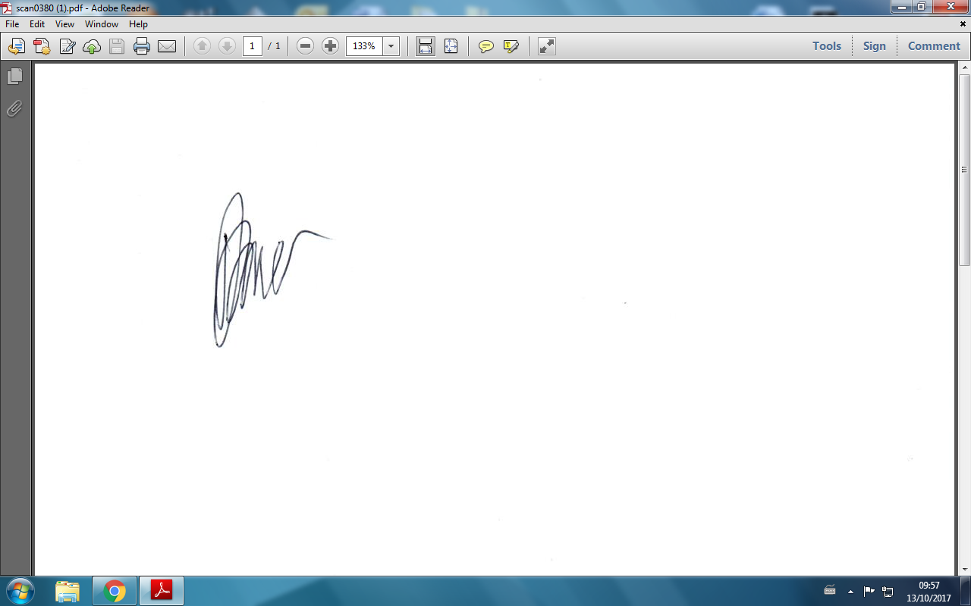

Mr T Kramer
Chair of Governors

