YEAR 3 | JOURNEY  (Aaron Becker)  NARRATIVE: Writing an ending/ sequel.  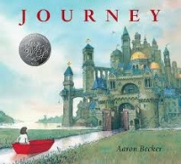  THE SNAIL AND THE WHALE  (Julia Donaldson)  Poetry:  Describing a character.  Persuasive Writing:  Letter for help.  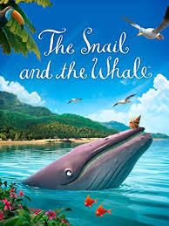 | MARCY AND THE RIDDLE OF THE SPHINX (Joe Todd Stanton)  To write a playscript.  To write a riddle – linked to mountains/rivers.  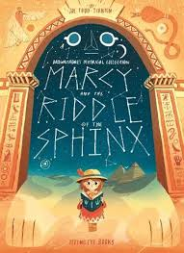  FILM UNIT: TADEO JONES  Diary entry – Informal tone.   | CHARLIE AND THE CHOCOLATE FACTORY  (Roald Dahl)  Explanation text: Sweet machine.  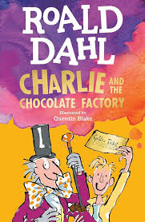  POETRY PERFORMANCE  EVENT | EYE OF THE WOLF  (Daniel Pennac)  Explanation text on deforestation.  NARRATIVE: The fox and the girl.  POETRY:  Emotive poem: Gorilla- deforestation  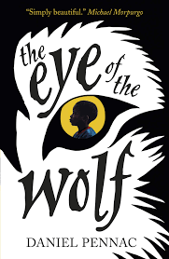 | WHO LET THE GOD’S OUT?  (Maz Evans)  Information text:  Create a care plan for a minotaur.  Persuasive writing:  Job application for a shop.  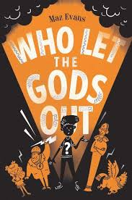 | JIM AND THE BEANSTALK  (BY Raymond Briggs)  NARRATIVE:  To write an alternative story.  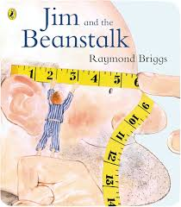  FILM UNIT: THE THREE LITTLE PIGS  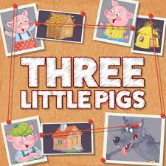
GRAMMAR | To write superlative and comparative adjectives. 3.3 3.4  To write a prepositional phrase within a compound sentence. 3.16  To convert spoken word into direct speech. 3.25  To distinguish between simple and compound sentences. 3.12  To write compound sentences with co-ordinating conjunctions (and, but, yet, or, so). 3.9, 3.10, 3.11, 3.18, 3.19 | To identify and write contractions.  To write adverbial phrases of time, place and manner. 3.8, 3.21, 3.22  To write superlative and comparative adjectives. 3.3 3.4 | To write adverbs that modify adjectives (extremely tasty). 3.5  To write exclamations. 3.2  To distinguish between simple and compound sentences. 3.12  To write a combination of simple and compound sentences. 3.20 | To write personal pronoun replace (his, her, she, him, they, we) nouns. 3.14, 3.15  Write apostrophes for singular possession. 3.23  Write apostrophes for plural possession. 3.24 | To write exclamations. 3.2  To write a combination of simple and compound sentences. 3. 20  To write compound sentences with co-ordinating conjunctions (and, but, yet, or, so). 3.9, 3.10, 3.11, 3.18, 3.19 | To convert spoken word into direct speech. 3.25  To write a combination of simple and compound sentences. 3.20  To write superlative and comparative adjectives. 3.3 3.4

