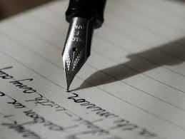 WRITING CURRICULUM
 | AUTUMN 1 | AUTUMN 2 | SPRING 1 | SPRING 2 | SUMMER 1 | SUMMER 2
YEAR 1 | FUNNYBONES  (Janet and Allan Ahlberg)  Wanted poster  Descriptive writing.  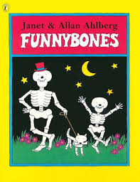 | BEEGU  (Alexis Deacon)  A letter  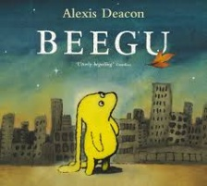  THE SMEDS AND THE SMOOS  (Julia Donaldson)  Persuasive writing.  Comparing the two texts.  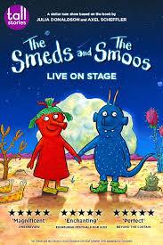 | FILM UNIT: BUBBLES  Setting Description- Beach  Sequencing a story  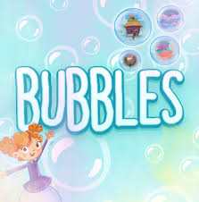  POETRY PERFORMANCE EVENT | THE STORM WHALE  (Benji Davies)  To make inferences about how a character feels.  NON- FICTION:  Facts about whales.  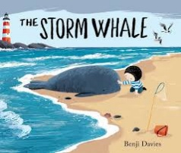  FAIRTALES.  LITTLE RED RIDNG HOOD  AND  RAPUNZEL  Writing a comparison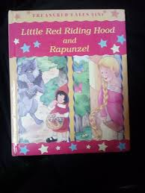 | THE DISGUSTING SANDWICH  (Gareth Edwards)  Recipe – Instructional writing.  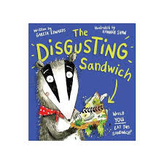 | BOB THE MAN ON THE MOON  Creating an advert to persuade somebody to go to the moon.  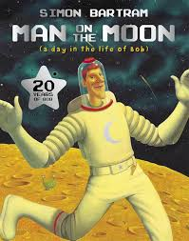  FILM UNIT: The way back home.  
GRAMMAR | To identify and use a capital letter to begin a sentence. 1.3  To identify and use a full stop to end a sentence. 1.3 | To identify and write an adjective after a state of being verb. 1.13  To identify and write two adjectives after a state of being verb. 1.14  To identify and write questions 1.17  To identify and use a capital letter to begin a sentence. 1.3  To identify and use a full stop to end a sentence. 1.3 | To identify and use a capital letter to begin a sentence. 1.3  To identify and use a full stop to end a sentence. 1.3 | To identify and write past tense action verbs. 1.1  To identify and write nouns. 1.7  To distinguish between statements and questions. 1.15  Write the stop mark for questions and statements. 1.16  To maintain a consistent past tense when writing. 1.5 | To identify and write personal pronouns as subjects. 1.10  To identify and write personal pronouns as objects. 1.11 | To identify and write a simple subject. 1.2  To identify and write a compound object. 1.9  To identify and write a compound subject. 1.8  To identify and write personal pronouns as subjects. 1.10  To identify and write an adjective after a state of being verb. 1.13  To identify and write two adjectives after a state of being verb. 1.14
YEAR 2 | THE GREAT KAPOK TREE  (Lynne Cherry)  To write information sentences on an animal.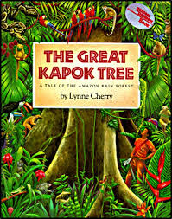 | TOBY AND THE GREAT FIRE OF LONDON.  (Margaret Nash and Jane Cope)  To write a recount.  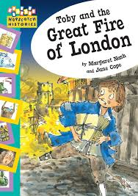 | RAVI’S ROAR  (Tom Percival)  To plan and write a section of a story.    POETRY PERFORMANCE  EVENT | GREGORY COOL  (Caroline Binch)  To write a descriptive postcard.  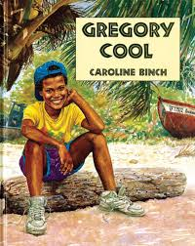 | ROSA PARKS  (Lisbeth Kaiser)  To write a newspaper article.  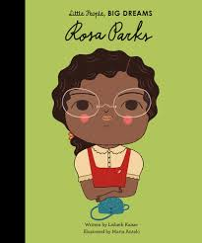 | LOOK UP  (Nathan Bryon)  To write a poem.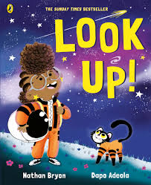
GRAMMAR | Identify and write lists of nouns joined with conjunctions. 2.2  To identify and write conjunctions to list nouns 2.3  Identify and write commas to list nouns. 2.4 | To identify and write adjectives before nouns acting as the subject. 2.11  To identify and write adjectives before nouns acting as the object. 2.12 | Identify and write adverbs of manner and time within a sentence. 2.19  To identify and write adverbs of manner that begin a sentence. 2.20 | To write adjectives before nouns acting as the subject/object. 2.11/2.12  To write apostrophes for contraction. 2.14 | Identify and write prepositional phrases of time, place and movement within simple sentences. 2.17  Identify and write prepositional phrases of time, place and movement that begin simple sentences. 2.18 | To identify and write adjectives before nouns acting as the subject. 2.11  To identify and write adjectives before nouns acting as the object. 2.12  To identify and write commas to list adjectives. 2.13
YEAR 3 | JOURNEY  (Aaron Becker)  NARRATIVE: Writing an ending/ sequel.  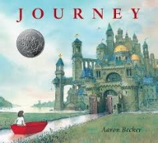  THE SNAIL AND THE WHALE  (Julia Donaldson)  Poetry:  Describing a character.  Persuasive Writing:  Letter for help.  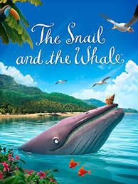 | MARCY AND THE RIDDLE OF THE SPHINX (Joe Todd Stanton)  To write a playscript.  To write a riddle – linked to mountains/rivers.  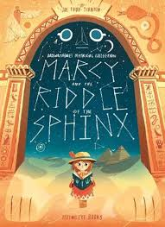  FILM UNIT: TADEO JONES  Diary entry – Informal tone.  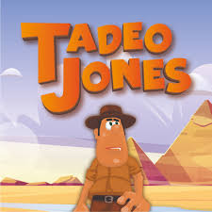 | CHARLIE AND THE CHOCOLATE FACTORY  (Roald Dahl)  Explanation text: Sweet machine.  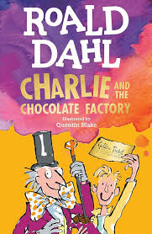  POETRY PERFORMANCE  EVENT | EYE OF THE WOLF  (Daniel Pennac)  Explanation text on deforestation.  NARRATIVE: The fox and the girl.  POETRY:  Emotive poem: Gorilla- deforestation  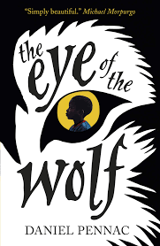 | WHO LET THE GOD’S OUT?  (Maz Evans)  Information text:  Create a care plan for a minotaur.  Persuasive writing:  Job application for a shop.  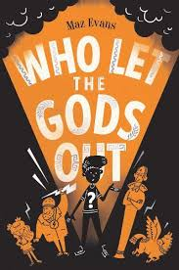 | JIM AND THE BEANSTALK  (BY Raymond Briggs)  NARRATIVE:  To write an alternative story.  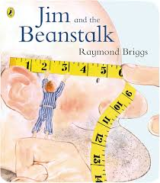  FILM UNIT: THE THREE LITTLE PIGS  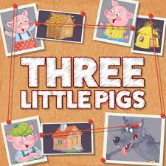
GRAMMAR | To write superlative and comparative adjectives. 3.3 3.4  To write a prepositional phrase within a compound sentence. 3.16  To convert spoken word into direct speech. 3.25  To distinguish between simple and compound sentences. 3.12  To write compound sentences with co-ordinating conjunctions (and, but, yet, or, so). 3.9, 3.10, 3.11, 3.18, 3.19 | To identify and write contractions.  To write adverbial phrases of time, place and manner. 3.8, 3.21, 3.22  To write superlative and comparative adjectives. 3.3 3.4 | To write adverbs that modify adjectives (extremely tasty). 3.5  To write exclamations. 3.2  To distinguish between simple and compound sentences. 3.12  To write a combination of simple and compound sentences. 3.20 | To write personal pronoun replace (his, her, she, him, they, we) nouns. 3.14, 3.15  Write apostrophes for singular possession. 3.23  Write apostrophes for plural possession. 3.24 | To write exclamations. 3.2  To write a combination of simple and compound sentences. 3. 20  To write compound sentences with co-ordinating conjunctions (and, but, yet, or, so). 3.9, 3.10, 3.11, 3.18, 3.19 | To convert spoken word into direct speech. 3.25  To write a combination of simple and compound sentences. 3.20  To write superlative and comparative adjectives. 3.3 3.4
YEAR 4 | ESCAPE FROM POMPEII.  (Christina Balit)  Third person recount.  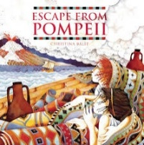 | THE DAY THE CRAYONS QUIT  (Drew Daywalt and Oliver Jeffers)  Persuasive Writing: letter.  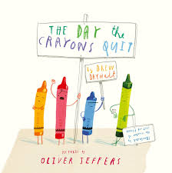 | THE TUNNEL  (Anthony Brown)  To write a balanced argument.  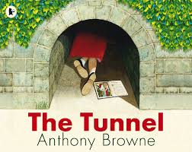  POETRY PERFORMANCE  EVENT | FILM UNIT:  THE LEGO STORY  Explanation text: The History of Lego.  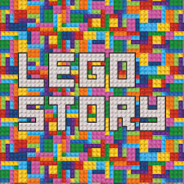 | THE NIGHT BUS  (Ohjali Q RAUF)  Playscript: Alternate ending.  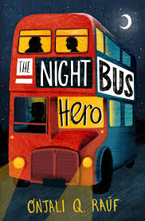 | THE LION, THE WITCH AND THE WARDROBE  (C.S LEWIS)  Poetry  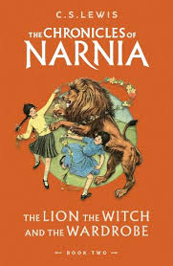  THE BOY WHO BIKED THE WORLD PART 1  (Alastair Humphreys)  Explanation text:  How to survive in the desert?  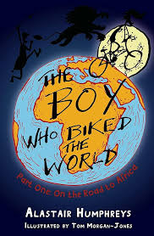
GRAMMAR | To distinguish between a main clause and a subordinate clause. 4.2  To identify, write and use subordinating conjunctions: because, when and although. 4.3  To identify and write complex sentences that open with a main clause followed by a subordinate clause. (because, when and although) 4.4  To identify and write complex sentences that open with a subordinate clause followed by a main clause. (because, when and although). 4.5 | To identify, write and use subordinating conjunctions: since, after/ before and even though. 4.9  To identify and write complex sentences that open with a main clause followed by a subordinate clause (since, after/before and even though). 4.10  To identify and write complex sentences that open with a subordinate clause followed by a main clause (since, after/before and even though). 4.11 | To identify and write compound sentences with semi-colons. 4.1  Identify and write the subordinating conjunctions as, while and if. 4.16  To identify and write complex sentences that open with a main clause followed by a subordinate clause (as, while and if) 4.17  To identify and write complex sentences that open with a subordinate clause followed by a main clause (as, while and if) 4.18 | To identify and write topic sentences that start new paragraphs in expositional writing. 4.6  To identify and write supporting detail that elaborates on topic sentences in expositional writing. 4.7  To identify and write concluding sentences that end paragraphs in expositional writing. 4.8 | To convert spoken word into direct speech (question and exclamation) starting with a reporting clause. 4.12  To convert spoken word into direct speech (statement starting with a reporting clause. 4.13  To identify and write appropriate verbs in reporting clauses for characterisation. 4.14  To identify and write new paragraphs for new speakers 4.15 | To identify and write compound sentences with semi-colons. 4.1  To identify and write sentences that open with present or past participles. 4.19  To identify and write sentences that open present or past participle phrases. 4.20
YEAR 5 | HOLES  (LOUIS SACHAR)  Non- Chronological report- yellow spotted lizard.  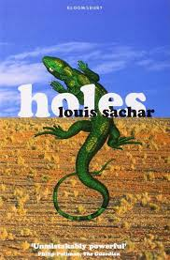 | BOY IN THE TOWER  (Polly Hayen)  Formal letter:  Closure of school  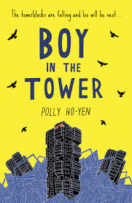  NARRATIVE:  Diary entry – different perspective. | NO BALLET SHOES IN SYRIA.  (Catherine Bruton)  Diary entry  Comparative description  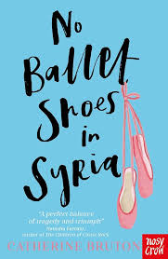  POETRY PERFORMANCE  EVENT | HIDDEN FIGURES  (Margot Lee Shetterly)  Non- Fiction – Webpage  Job advert- vacancy in Nasa  Diary entry  Newspaper article.  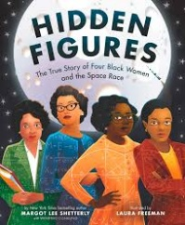 | CLOUDBUSTING  (Malorie Blackman)  Poetry  Persuasive speech – Bullying.  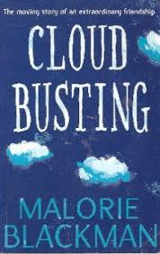 | FILM UNIT: OKTAPODI  To write a monologue speech.  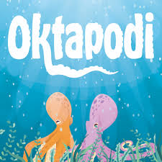
GRAMMAR | To identify and write similes 5.17  To identify and write metaphors 5.18  To identify and write personification 5.19 | To identify and write expanded noun phrases that include a prepositional phrase 5.2  To identify and write relatives clauses as. 5.3  To write relative clauses and appositives within compound and complex sentences 5.6  To identify and write conjunctive adverbs after semi-colons to combine and link two main clauses. 5.14 | To identify and write an introductory paragraph in expositional writing. 5.15  To identify and write a concluding paragraph in expositional writing. 5.16  To identify and write ellipsis as a pause. 5.12  To identify and write ellipsis as a stop mark and an incomplete thought 5.11 | To convert spoken word into direct speech where the reporting clause is embedded. 5.8  To open, embed or end a paragraph with direct speech. 5.9  To expand on direct speech with narrative to advance the plot 5.10 | To identify and write conjunctive adverbs to open sentences. 5.13  To identify and write metaphors 5.18  To identify and write adverbs followed by present and past participles openers. 5.1 | To convert spoken word into direct speech where the reporting clause is embedded. 5.8  To open, embed or end a paragraph with direct speech. 5.9  To expand on direct speech with narrative to advance the plot 5.10
YEAR 6 | SKELLIG  (David Almond)  NARRATIVE:  To write a suspense narrative.  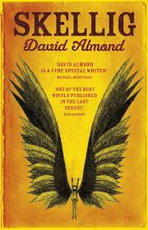  NARRATIVE:  FILM UNIT: FRANCIS  To write a suspense narrative.  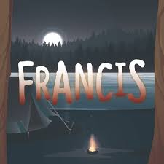 | EVEREST  (Alexander Stewart and Joe Todd- Stanton)  Diary entry  Information text about Everest.  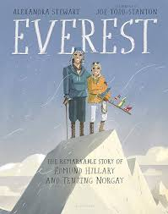  POETRY:  FILM UNIT: DREADFUL MENACE.  To write a poem.  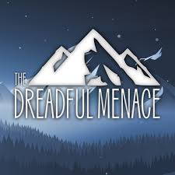 | MACBETH RETOLD  (Andrew Matthews and Tony Ross)  To write a balanced debate.  Newspaper report: the death of King Duncan.  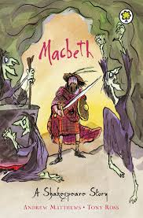  POETRY PERFORMANCE  EVENT | CARRIE’S WAR (by Nina Bowden)  To write an emotive letter.  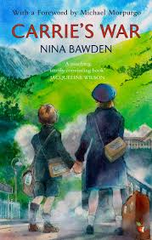 | THE FINAL YEAR  (Matt Goodfellow)  To write a diary entry.  To write about myself in verse.  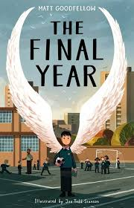 | FILM UNIT: ALMA  NARRATIVE:  Suspense narrative with dialogue.  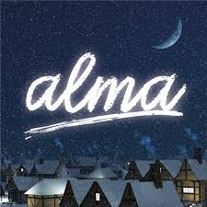
GRAMMAR | To identify and write multi-clause compound sentences joined with two coordinating conjunctions. 6.1  To identify and write multi-clause complex sentences joined with two subordinating conjunctions. 6.2  To identify and write multi-clause complex sentences joined with one subordinating conjunction and one co-ordinating conjunction. 6.3  Identify and write a combination of sentence types to avoid repetition. 6.4  To identify and write single sentence paragraphs to enhance the mood, add emphasis and alter the pace of the narrative. 6.13  To identify and write epistrophe. 6.15  To identify and write cohesive paragraphs where the topic sentence links to the proceeding concluding sentence. 6.12  To identify and use dashes and ellipses in direct speech for characterisation. 6.9 | To distinguish between active and passive voice. 6.8  To identify and write cohesive paragraphs where the topic sentence links to the proceeding concluding sentence. 6.12  To identify and write exaggeration. 6.16  To identify and write simple sentences to enhance the mood or add emphasis. 6.5  To identify and use dashes and ellipses in direct speech for characterisation. 6.9  To identify and write single sentence paragraphs to enhance the mood, add emphasis and alter the pace of the narrative. 6.13  To identify and write anaphora. 6.14 | To identify and use colons to introduce lists. 6.6  To identify and use colons to explain. 6.7  To identify and use epistrophe. 6.15 | To identify and use colons to introduce lists. 6.6  To identify and use colons to explain. 6.7  To identify and write epistrophe. 6.15 | To identify and use dashes and ellipses in direct speech for characterisation. 6.9  To identify and write single sentence paragraphs to enhance the mood, add emphasis and alter the pace of the narrative. 6.13  To identify and write simple sentences to enhance the mood or add emphasis. 6.5  To identify and write conjunctive adverbs to link paragraphs. 6.11 | To identify and use dashes and ellipses in direct speech for characterisation. 6.9  To identify and write multi-clause complex sentences joined with one subordinating conjunction and one co-ordinating conjunction. 6.3  To identify and write epistrophe. 6.15  To identify and write cohesive paragraphs where the topic sentence links to the proceeding concluding sentence. 6.12  To identify and write non-standard English in direct speech for characterisation. 6.10  To identify and write cohesive paragraphs where the topic sentence links to the proceeding concluding sentence. 6.12

*The grammar objectives for each year group are based on the Stanley Road grammar curriculum.

