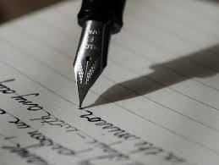 WRITING CURRICULUM
 | AUTUMN 1 | AUTUMN 2 | SPRING 1 | SPRING 2 | SUMMER 1 | SUMMER 2
YEAR 4 | ESCAPE FROM POMPEII.  (Christina Balit)  Third person recount.  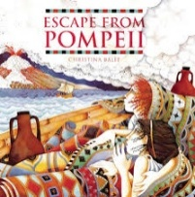 | THE DAY THE CRAYONS QUIT  (Drew Daywalt and Oliver Jeffers)  Persuasive Writing: letter.  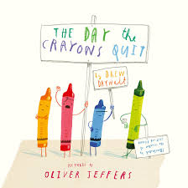 | THE TUNNEL  (Anthony Brown)  To write a balanced argument.  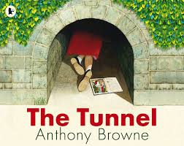  POETRY PERFORMANCE  EVENT | FILM UNIT:  THE LEGO STORY  Explanation text: The History of Lego.   | THE NIGHT BUS  (Ohjali Q RAUF)  Playscript: Alternate ending.  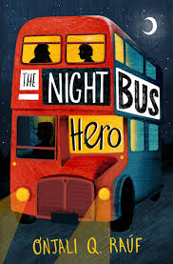 | THE LION, THE WITCH AND THE WARDROBE  (C.S LEWIS)  Poetry  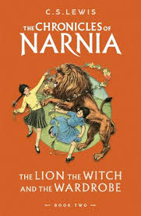  THE BOY WHO BIKED THE WORLD PART 1  (Alastair Humphreys)  Explanation text:  How to survive in the desert?  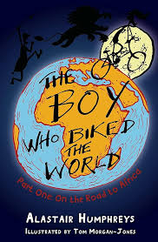
GRAMMAR | To distinguish between a main clause and a subordinate clause. 4.2  To identify, write and use subordinating conjunctions: because, when and although. 4.3  To identify and write complex sentences that open with a main clause followed by a subordinate clause. (because, when and although) 4.4  To identify and write complex sentences that open with a subordinate clause followed by a main clause. (because, when and although). 4.5 | To identify, write and use subordinating conjunctions: since, after/ before and even though. 4.9  To identify and write complex sentences that open with a main clause followed by a subordinate clause (since, after/before and even though). 4.10  To identify and write complex sentences that open with a subordinate clause followed by a main clause (since, after/before and even though). 4.11 | To identify and write compound sentences with semi-colons. 4.1  Identify and write the subordinating conjunctions as, while and if. 4.16  To identify and write complex sentences that open with a main clause followed by a subordinate clause (as, while and if) 4.17  To identify and write complex sentences that open with a subordinate clause followed by a main clause (as, while and if) 4.18 | To identify and write topic sentences that start new paragraphs in expositional writing. 4.6  To identify and write supporting detail that elaborates on topic sentences in expositional writing. 4.7  To identify and write concluding sentences that end paragraphs in expositional writing. 4.8 | To convert spoken word into direct speech (question and exclamation) starting with a reporting clause. 4.12  To convert spoken word into direct speech (statement starting with a reporting clause. 4.13  To identify and write appropriate verbs in reporting clauses for characterisation. 4.14  To identify and write new paragraphs for new speakers 4.15 | To identify and write compound sentences with semi-colons. 4.1  To identify and write sentences that open with present or past participles. 4.19  To identify and write sentences that open present or past participle phrases. 4.20

*The grammar objectives for each year group are based on the Stanley Road grammar curriculum.

