YEAR 5 | HOLES  (LOUIS SACHAR)  Non- Chronological report- yellow spotted lizard.  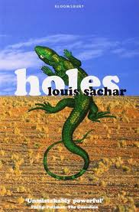 | BOY IN THE TOWER  (Polly Hayen)  Formal letter:  Closure of school  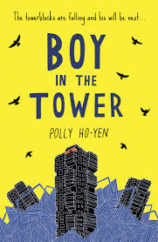  NARRATIVE:  Diary entry – different perspective. | NO BALLET SHOES IN SYRIA.  (Catherine Bruton)  Diary entry  Comparative description  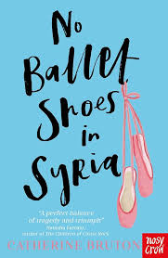  POETRY PERFORMANCE  EVENT | HIDDEN FIGURES  (Margot Lee Shetterly)  Non- Fiction – Webpage  Job advert- vacancy in Nasa  Diary entry  Newspaper article.  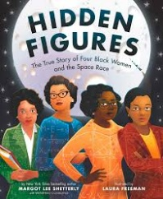 | CLOUDBUSTING  (Malorie Blackman)  Poetry  Persuasive speech – Bullying.  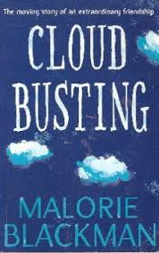 | FILM UNIT: OKTAPODI  To write a monologue speech.  
GRAMMAR | To identify and write similes 5.17  To identify and write metaphors 5.18  To identify and write personification 5.19 | To identify and write expanded noun phrases that include a prepositional phrase 5.2  To identify and write relatives clauses as. 5.3  To write relative clauses and appositives within compound and complex sentences 5.6  To identify and write conjunctive adverbs after semi-colons to combine and link two main clauses. 5.14 | To identify and write an introductory paragraph in expositional writing. 5.15  To identify and write a concluding paragraph in expositional writing. 5.16  To identify and write ellipsis as a pause. 5.12  To identify and write ellipsis as a stop mark and an incomplete thought 5.11 | To convert spoken word into direct speech where the reporting clause is embedded. 5.8  To open, embed or end a paragraph with direct speech. 5.9  To expand on direct speech with narrative to advance the plot 5.10 | To identify and write conjunctive adverbs to open sentences. 5.13  To identify and write metaphors 5.18  To identify and write adverbs followed by present and past participles openers. 5.1 | To convert spoken word into direct speech where the reporting clause is embedded. 5.8  To open, embed or end a paragraph with direct speech. 5.9  To expand on direct speech with narrative to advance the plot 5.10

