St Edmund’s Catholic Primary School


Healthy Food And

Lunches Policy

September 2024

Contents

- Introduction and aims  - Food in the curriculum  - Playground fruit  - School lunches  - Packed lunches  - Partnership with parents / carers  - Dissemination of policy  - Monitoring and review | 1  1  2  2  2  4  4  4

- Introduction and aims
St Edmund’s recognises that our children come from diverse home backgrounds, cultures, and ethnic groups. Our school aims to meet the needs of all children and ensure equality of provision, whilst taking account of this diversity and difference. We will provide a safe, healthy and appealing eating environment for pupils at lunch time, and ensure fresh drinking water is available at all times. We will encourage all pupils to eat and drink as much of their morning fruit or lunch as possible. As fridge space is not available in school, parents are advised to send in packed lunches in a cooler bag or food that does not require refrigeration.

This policy has been drawn up with the following aims:

- To ensure the contents of lunchboxes reflect the requirements of schools, to meet minimum food and nutrition standards for school meals;
- To make a positive contribution to children’s health by encouraging healthy eating habits in childhood that can influence health and wellbeing in later life;
- To take a proactive approach to promoting healthy eating;
- To give clear guidance to parents/carers, pupils, governors and staff on providing a healthy packed lunch;
- To equip pupils with the skills, knowledge and understanding to enable them to make informed healthy lifestyle choices based on their nutritional understanding;
- To ensure that all children have a healthy and nutritious midday meal that sustains and prepares them for their afternoon learning.

Food in the curriculum
Food, its production and preparation is an important part of the curriculum. Pupils are taught from Year 2 in cooking classes as well as across the curriculum in science, PSHE, PE and other enrichment activities. Food related issues including food hygiene and safety are also taught in line with national curriculum expectations.

Playtime Fruit
All Foundation Stage, Year 1 and Year 2 children are provided with daily fruit or vegetables as part of a Government Scheme. Milk is provided free for under-fives.

In Key Stage 2, children are allowed and encouraged to bring in a piece of fresh fruit or vegetables to eat during morning break. No other snacks are allowed.

Nut-free school:
Due to the risk to those who have intolerance to and / or serious allergic reactions to nuts, St Edmund’s makes every effort to be a nut free school. This is enforced, as well as possible, in school through a ban on nuts, nut products or products that may contain traces of nuts.
However, the practicality of policing all food on premises makes this very difficult. Off the premises, on a school trip for example, pupils with these allergies must take their Epipens with them and be supported by a member of staff who is capable of helping administer it. Staff who accompany children on school trips have all had training in the use of Epipens.

Allergies
All staff are aware of children who have allergies and this is recorded on Scholar Pack along with an ‘Allergy Sheet’ given to teachers and kitchen staff. Those staff serving children hot lunches will refer to sheet / labels ensuring all children are catered for correctly.

Water
It has been recognised that children’s concentration and behaviour improves when children drink water throughout the day. Dehydration can give children headaches and make them tired. Therefore, we encourage all pupils to bring a re-useable bottle of water to school each day. These can be kept at school and will be filled and emptied each day. This will allow children to have access to fresh drinking water throughout each day.

School lunches
All our school meals are provided by a contracted caterer Stir, who acts in accordance with the School Food Standards. A copy of the weekly menu is on display on the school website. The menu is also available via the school office if requested. The dining area is a calm and positive atmosphere, where children socialise and enjoy the dining experience. Staff monitor food choices and encourage pupils to try new foods, we encourage all parents to take free school meals, where there is an entitlement.

Packed lunches
Parents / Carers who do not have school lunches are expected to provide their children with packed lunches that are consistent with the nutritional standards based on the Eatwell Guide and School Food Trust guidelines. (Appendix 1)

Recommended ideas for healthy lunch boxes:
- Fruit and vegetables; at least two portions of fruit or vegetables every day. This could be fresh, dried or tinned fruit.
- Carbohydrate; a starchy food every day such as bread, pasta, rice, couscous, noodles, potatoes, chapatis /roti, plain crackers, breadsticks, rice cakes
- Protein; meat, egg or other source of non-dairy protein such as lentils, kidney beans, chickpeas, hummus, dhal, falafel
- Oily fish; tinned or fresh mackerel, sardines, salmon or tuna should be included at least once every three weeks
- Dairy; every day such as milk, cheese, yoghurt, fromage-frais, custard or calcium fortified soya products - reduced fat if possible
- Drinks; (with no added sugar) such as pure fruit juice, semi skimmed/skimmed milk, milk-based or yoghurt-based drinks, fruit smoothies
- Dessert/pudding; such as a small cake, biscuit, cereal bar, fruit loaf/bun OR scotch pancake as part of a balanced meal. Please look carefully at packaging as many items that may look healthy can have high levels of sugar and fat. Look for those with 100 calories or less per portion and only include one-a-day for lunch.

Packed Lunches should not include:
- Sweets/confectionery/chewing gum
- Fizzy or sugary drinks
- Energy drinks
- Crisps
- Items containing nuts are not allowed in school. Although these are healthy, some children are allergic to nuts and they can cause a severe reaction even when in other pupils’ lunches.

For a healthier meal:
- Replace cakes and pastries with fruit bread
- Replace salted savoury snacks, such as crisps, with breadsticks, rice cakes, cheese and crackers or popcorn (not sweet or toffee)
- Include dried fruit or fruit salad
- Drink water, milk, 100% fruit juice, fruit smoothie, or yoghurt drink.

Children who eat school dinners will be asked to choose a vegetable or salad item as part of their lunch.

Special Diets and allergies:
- The school recognises that some pupils may require special diets that do not follow the above exactly. In this case parents/carers are asked to inform the school and make their child’s lunchbox as healthy as possible. For this reason, and due to allergies, pupils are not permitted to swap food items.

PLEASE DO NOT SEND YOUR CHILDREN WITH NUTS OR FOOD CONTAINING NUTS
OR TRACES OF NUTS (for example, Nutella or Bombay Mix) AS WE HAVE NUMBER OF CHILDREN WITH NUT ALLERGIES.

Provision for Packed Lunches
- School will provide dining room facilities where pupils can eat their lunches.
- School will ensure that fresh drinking water is readily available at all times.

Lunch Containers
We ask that parents/carers and pupils:
- provide a packed lunch container where food items can be stored securely and appropriately until the lunchtime period;
- bring packed lunches in reusable plastic containers, rather than disposing of plastic bags and bottles.
- Fridge space for packed lunches is not available so it is advisable to bring packed lunches in insulated bags with an ice pack to keep the food fresh.

Waste and disposal
- The school will, within reason, send any uneaten packed lunch food items back home. The rationale for this is that parents can also monitor what their child has consumed during the day and then raise any concerns over their child’s food intake with the school.

Birthdays:
We are aware many parents like to celebrate their child’s birthday in school as well as at home, however, we do not allow any cake or sweets into school (including the playground) for this purpose.

Other occasions:
At St Edmund’s we recognise that there is no such thing as ‘bad food’, and therefore teach the children to enjoy ‘treats’ in moderation. Occasionally, during a special event, i.e. cake sale, Hot Choc Friday, Christmas parties. On these occasions, nuts will still not be allowed in school and children reminded this is a ‘treat’.
During SATs week, all Year 6 pupils are offered a free healthy breakfast.

Partnership with parents / carers
The school is aware that the primary role models in children’s healthy eating education are parents / carers. We wish to build a positive and supportive relationship with the parent / carers of children at our school through mutual understanding, trust and co-operation. In promoting this objective we will:
- Inform parents / carers about the school healthy snack and lunches policy and practice;
- Inform parents / carers about the best practice known with regard to healthy eating so that the parents / carers can support the key messages being given to children at school.

Dissemination of policy
The school will write to all new and existing parents / carers to inform them of this policy.

The policy will be available on the school’s website and will be incorporated into the school prospectus and assemblies.

The school will use opportunities such as parent / carers evenings and Healthy Living weeks to promote this policy as part of a whole school approach to healthier living.

All school staff, including teaching and catering staff will be informed of this policy and will support its implementation.

Monitoring and review
This policy will be monitored and reviewed by the Headteacher annually with support from all school staff, parents / carers and children.
The contents of packed lunches will be monitored by teachers and lunch time supervisors. Parents / carers of children whose packed lunches do not comply with this policy will be reminded of this policy.

Review: September 2025

Appendix 1
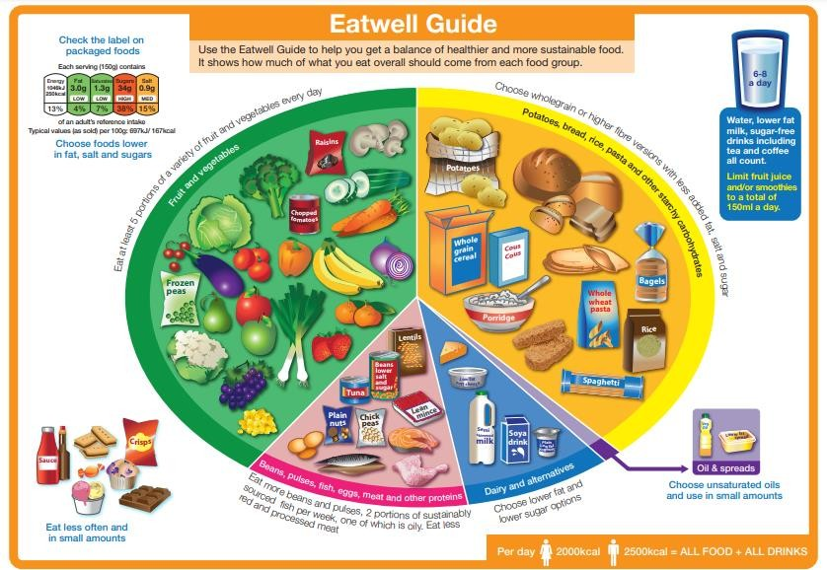

The Eatwell Guide Booklet

https://assets.publishing.service.gov.uk/government/uploads/system/uploads/attachment_dat a/file/742750/Eatwell_Guide_booklet_2018v4.pdf

The School Food Standards Guidance https://assets.publishing.service.gov.uk/government/uploads/system/uploads/attachment_dat a/file/847621/School-Food-Standards-Guidance-FINAL-V3.pdf

